**Ex No: 2**

**Date:**

**DESIGN OF CAMPUS AREA NETWORK WITHIN A COLLEGE CAMPUS.**

**Aim:**

A newly constructed block in your college is planning to provide internet connection and also wants to make all the computers available in the block to be interconnected. The new block is of ‘m’ floors and overall ‘n’ rooms in each floor, also it has three buildings in its campus with the same capacity which are separated by ‘x’ meters.

* 1. Identify the networking devices required for constructing the suitable network.
  2. List the features of the networking devices.

Recommend and design the best suitable network type based on installation cost, performance, maintenance, and installation time.

**Theory:**

To provide an effective and interconnected network for the newly constructed block in a college, it is essential to identify the appropriate networking devices and network type. Here's a step-by-step guide to designing a suitable network for the scenario described:

1. **Networking Devices Required:**

* **Routers**:

Routers connect different networks, allowing communication between them. They are crucial for internet connectivity and routing data between the local network and the internet.

* **Switches**:

Switches connect multiple devices within the same network, enabling them to communicate efficiently. They manage data traffic and ensure that data is sent only to its intended destination within the network.

* **Access Points (APs)**:

Access points provide wireless connectivity to devices. They extend the wired network by creating a wireless local area network (WLAN), enabling mobile devices to connect to the internet and the local network.

* **Network Cables (Ethernet cables, Fiber optic cables)**:

These cables physically connect devices to the network. Ethernet cables are commonly used within buildings, while fiber optic cables are ideal for connecting different buildings over longer distances due to their higher bandwidth and lower latency.

1. **Features of the Networking Devices**

* **Routers:**
* Dynamic routing capabilities
* Support for multiple network protocols (e.g., IPv4, IPv6)
* Quality of Service (QoS) features for traffic management
* Built-in firewall and VPN support
* **Switches:**
* High port density for connecting many devices
* Support for VLANs (Virtual LANs) for network segmentation
* PoE (Power over Ethernet) support for powering devices like IP cameras
* Layer 2 and Layer 3 switching capabilities
* **Access Points:**
* Support for the latest Wi-Fi standards (e.g., Wi-Fi 6)
* Seamless roaming and load balancing features
* Multiple SSIDs for different user groups
* Security features like WPA3 encryption
* **Network Cables:**
* Ethernet cables: Cat5e, Cat6, or Cat6a for different speed and distance requirements
* Fiber optic cables: Single-mode or multi-mode for high-speed long-distance connections

1. **Recommended Network Type**

Network Type: Campus Area Network (CAN)

**Reasons for Recommendation**:

* **Installation Cost**: Moderate cost as it utilizes existing Ethernet and fiber optic cabling infrastructure efficiently.
* **Performance**: High performance with the use of fiber optics for building interconnectivity and gigabit Ethernet within buildings.
* **Maintenance**: Relatively low maintenance due to centralized management capabilities in modern networking equipment.
* **Installation Time**: Moderate installation time, leveraging structured cabling systems and modular network components.

**Design Overview**:

**Wired Backbone**:

* Use fiber optic cables to connect the three buildings, ensuring high-speed data transfer and minimal latency.

**In-Building Network**:

* + Deploy gigabit Ethernet switches on each floor to connect rooms and provide reliable wired connections.
  + Use VLANs to segment the network logically for different departments or functions.

**Wireless Network**:

* + Install access points throughout the floors to provide wireless connectivity, ensuring coverage in all rooms and common areas.

**Internet Connectivity**:

* + Use a high-performance router to connect the entire block to the internet, with redundancy options to prevent downtime.

This design ensures that the college's new block has a robust, high-performance network that supports current needs and future expansion.

**Procedure:**

For a campus with three blocks, namely, UG block, Admin block and newly added PG block, with following setup,

Admin Block – 136 hosts (68 per floor)

UG Block – 96 hosts (48 per floor)

PG Block – 52 hosts (26 per floor)

and assuming the original IP address assigned for the entire network is 192.168.1.0, the following procedure can be implemented, employing ***subnetting.***

***ADMIN BLOCK:***

136 hosts required.

Hence 256 host addresses can be provided to cover required 136.

256 = 28

No. of host addresses available = 28 – 2 = 256 – 2 = 254

No. of bits required for host address = 8

No. of bits required for network address = 32-8 = 24

**Subnet mask representation: 192.168.1.0/24**

**Subnet IP address : 192.168.1.0**

**Subnet mask : 255.255.255.0** (11111111 11111111 11111111 00000000)

**Range of available IP addresses:**

First IP address: 192.168.1.1

Last IP address: 192.168.1.254

***UG BLOCK:***

96 hosts required.

Hence 128 host addresses can be provided to cover required 96.

128 = 27

No. of host addresses available = 27 – 2 = 128 – 2 = 126

No. of bits required for host address = 7

No. of bits required for network address = 32-7 = 25

**Subnet mask representation: 192.168.2.0/25**

**Subnet IP address : 192.168.2.0**

**Subnet mask : 255.255.255.128** (11111111 11111111 11111111 10000000)

**Range of available IP addresses:**

First IP address: 192.168.2.1

Last IP address: 192.168.2.126

***NEW PG BLOCK***

52 hosts required.

Hence 64 host addresses can be provided to cover required 52.

64 = 26

No. of host addresses available = 26 – 2 = 64 – 2 = 62

No. of bits required for host address = 6

No. of bits required for network address = 32-6 = 26

**Subnet mask representation: 192.168.2.0/26**

**Subnet IP address : 192.168.2.128**

**Subnet mask : 255.255.255.192** (11111111 11111111 11111111 11000000)

**Range of available IP addresses:**

First IP address: 192.168.2.129

Last IP address: 192.168.2.190

***ROUTER CONFIGURATION***

3 routers minimum required, 1 for each of 3 blocks.

One router, commonly connected to other 2 routers.

**Note: 1 router cannot have 2 serial connections with same IP domain.** Hence IP address for newly established PG block is assigned a different IP address extension.

***Router 1 (ADMIN Block) & Router 2(UG Block) :***

4 host addresses can be provided to cover required **2 routers (UG block & PG Block).**

4 = 22

No. of host addresses available = 22 – 2 = 4 – 2 = 2

No. of bits required for host address = 2

No. of bits required for network address = 32-2 = 30

**Subnet mask representation: 192.168.2.0/30**

**Subnet IP address : 192.168.2.192**

**Subnet mask : 255.255.255.252** (11111111 11111111 11111111 11111100)

**Range of available IP addresses:**

First IP address: 192.168.2.193

Last IP address: 192.168.2.194

***Router 3 (PG Block)***

Hence 4 host addresses can be provided.

4 = 22

No. of host addresses available = 22 – 2 = 4 – 2 = 2

No. of bits required for host address = 2

No. of bits required for network address = 32-2 = 30

**Subnet mask representation: 192.168.3.0/30**

**Subnet IP address : 192.168.3.0**

**Subnet mask : 255.255.255.252** (11111111 11111111 11111111 11111100)

**Range of available IP addresses:**

First IP address: 192.168.3.1

Last IP address: 192.168.3.2

***Router 1 (ADMIN Block)***

**Fastethernet 0/0 :**

IP:192.168.1.100, Subnet mask : 255.255.255.0

**Se 2/0 :**

IP:192.168.2.193, Subnet mask : 255.255.255.252

**Se 3/0 :**

IP:192.168.3.1, Subnet mask : 255.255.255.252

***Router 2(UG Block)***

**Fastethernet 0/0 :**

IP:192.168.2.100, Subnet mask : 255.255.255.128

**Se 2/0 :**

IP:192.168.2.194, Subnet mask : 255.255.255.252

***Router 3(PG Block)***

**Fastethernet 0/0 : s**

IP:192.168.2.190, Subnet mask : 255.255.255.192

**Se 2/0 :**

IP:192.168.3.2, Subnet mask : 255.255.255.252

**Simulation Output/Output:**

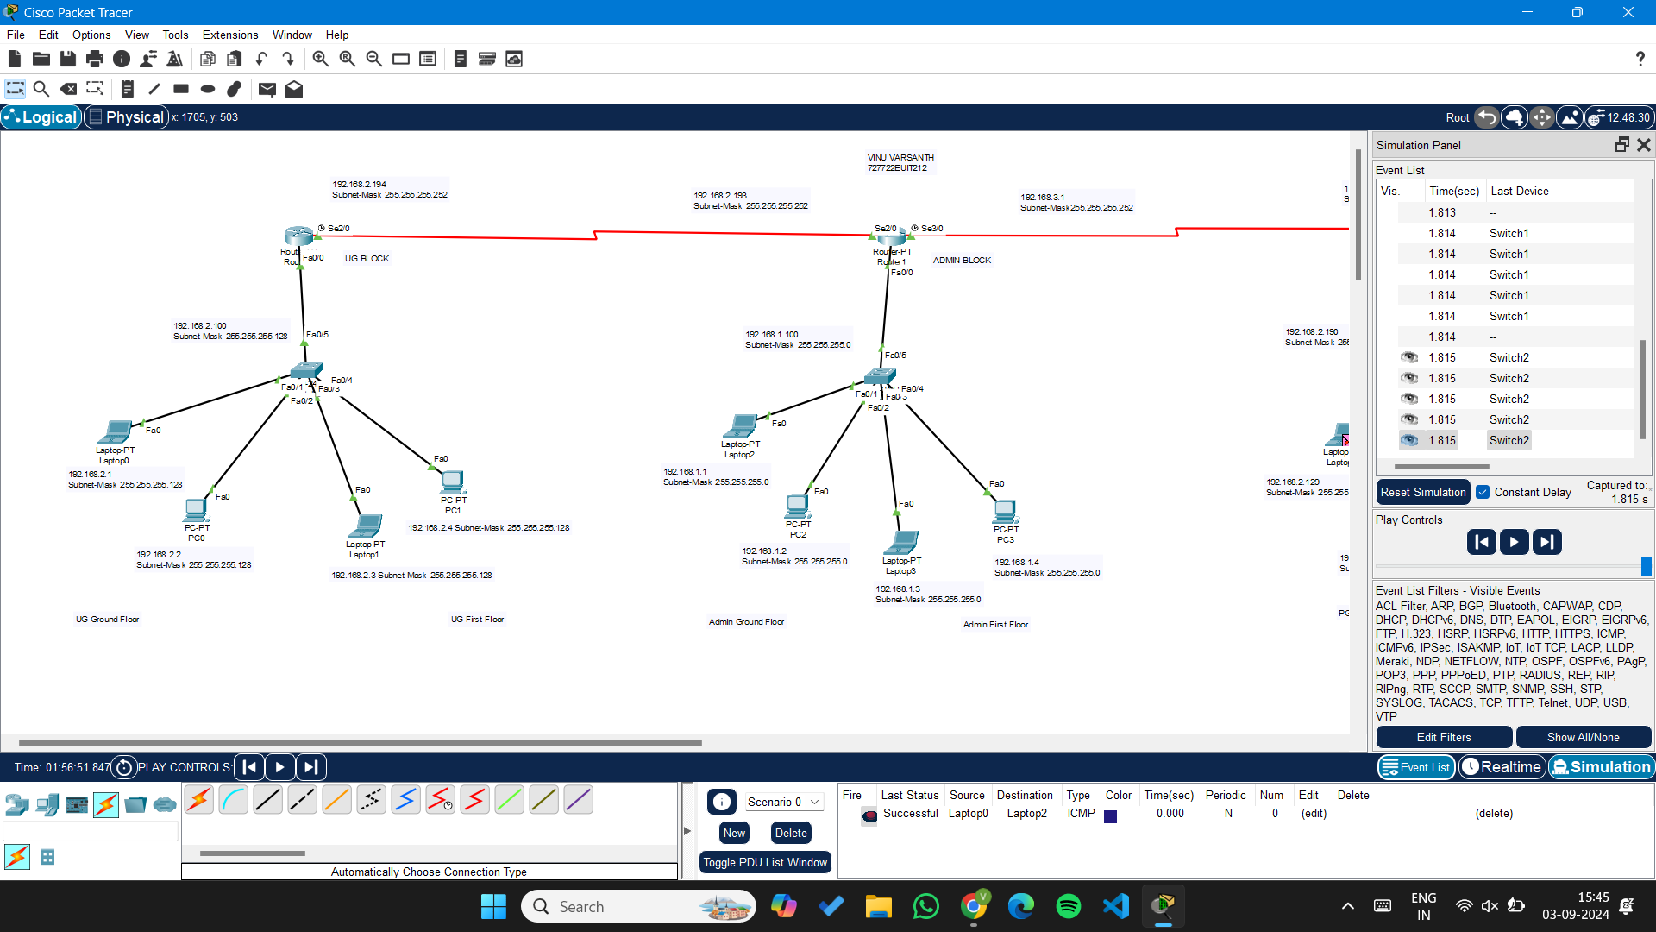

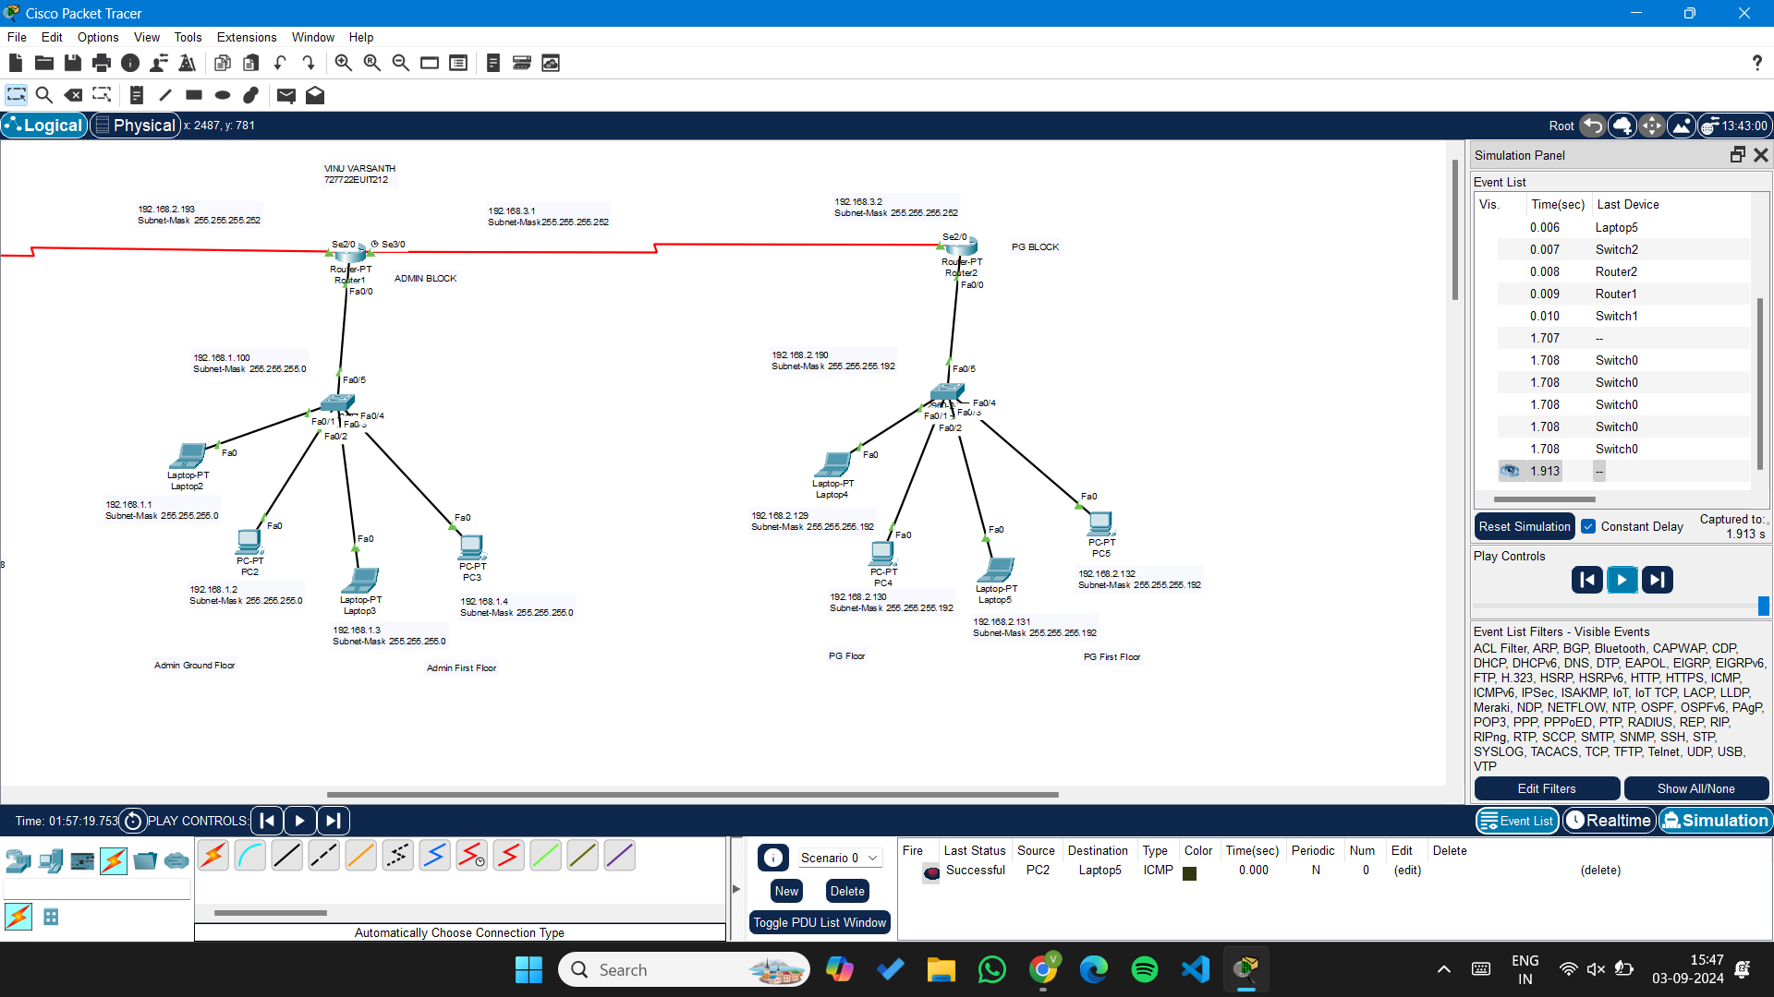

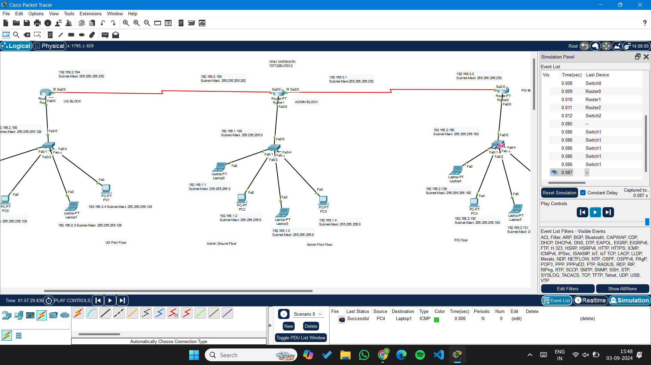

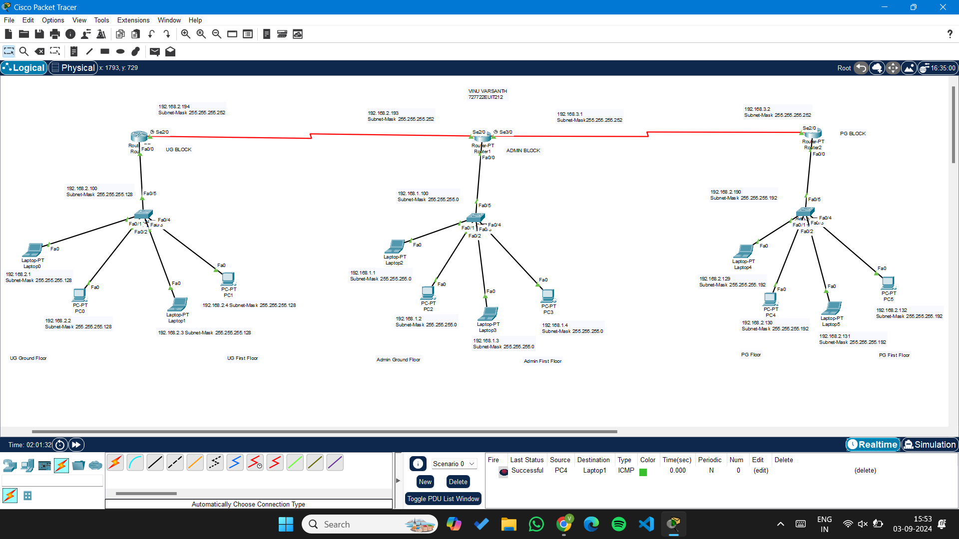

**Result:**

Thus, a Campus Area Network was established, employing subnetting and providing a reliable network for a new PG Block, along with 2 existing blocks, UG block and Admin Block. The design was implemented and communication simulated successfully, on Cisco Packet tracer platform.